## “ Help’em : A Disaster Management system”

***A***

***Project Progress Report*** *submitted in partial fulfilment of the*

*requirements for the award of the degree of*

**BACHELOR OF TECHNOLOGY**

**In**

**COMPUTER SCIENCE & ENGINEERING**

|  |  |
| --- | --- |
| **Student Name** | **Roll No.** |
| Himanshu Rawat  Mohit Singh Bhoj  Aanchal Negi | 190228  190238  190201 |
| Simmy Bisht | 220212 |

**By**

**Under the guidance of**

**Dr. Jitendra Singh Rauthan**

(Professor)

Department Of Computer Science & Engineering



**G.B Pant Institute of Engineering & Technology, Pauri , Uttarakhand**

**Nov 2022**

**TABLE OF CONTENTS**

**S.NO.** **Contents Page No**

1. Abstract 3

2. Introduction 4

3. Technologies Used 5

4. System requirements 7

5. Objectives 8

6. Roadmap 9

7. Architecture 10

8. Project Progress 11

9. Next Steps 18

10. References 18

**ABSTRACT**

The following report contains information about the post-disaster management system.

In times of disaster, it is a difficult task to manage the humongous crowd filled with fear. Providing them with shelter and food gets tough. This is where our platform comes in handy.

It gives a chance to a commoner to step forward and voluntarily help those helpless people by providing shelter. Other than this, our platform will help the family members in locating their lost ones if they are in any of the shelters under us.

**INTRODUCTION**

Disaster situations are threatening, highly dynamic, and with uncertain developments. It is difficult to predict human behaviour when hit by a Disaster as this depends on unknown and irrational factors. National disaster task forces such as NDRF have been experiencing such situations while evacuating the areas under the influence of disasters like earthquakes, floods, cyclones, and other calamities.

It is vital to evaluate the disaster-struck areas, understand the requirements at the ground level and use the resources present at the moment optimally. There is a requirement to create a system to manage and minimize the aftermaths of a disaster.

So, we present a solution to this by developing a platform where various people grant their homes, shops, etc., for shelter purposes. The platform can be used by the family of the victim to find his location or whether he is safe or not.

The platform will help in improving the facilities provided to the victims by sheltering them and managing the crowd effectively.

**TECHNOLOGIES USED**

**Frontend**

**JavaScript** - JavaScript is a programming language that is one of the core technologies of the World Wide Web, alongside HTML and CSS. In this project, JavaScript is used on the front end for creating different functions for rendering data on pages.

**React Native**- React Native lets you create truly native apps and doesn't compromise your users' experiences. It provides a core set of platform agnostic native components that map directly to the platform’s native UI building blocks.

**React** - React makes it painless to create interactive UIs. Design simple views for each state in your application, and React will efficiently update and render just the right components when your data changes.

**Backend**

**MongoDB –** MongoDB is an open-source NoSQL database management program. NoSQL is used as an alternative to traditional relational databases. NoSQL databases are quite useful for working with large sets of distributed data. MongoDB is a tool that can manage document-oriented information and store or retrieve information.

**NodeJS –** Node.js is an open-source, cross-platform, back-end JavaScript runtime environment that runs on a JavaScript Engine and executes JavaScript code outside a web browser, which was designed to build scalable network applications.

**ExpressJS -** Express.js, or simply Express, is a back-end web application framework for Node.js, released as free and open-source software under the MIT License. It is designed for building web applications and APIs. It has been called the de facto standard server framework for Node.js.

**Other Technologies used**

**Git** -

A free and open-source distributed version control system. It tracks changes in any set of files, usually used for coordinating work among programmers. Used GitHub to implement version control in this project.

**VSCode -**

Code editor made by Microsoft for Windows, Linux and macOS. Used as the primary code editor in the project.

**HARDWARE AND SOFTWARE REQUIREMENTS**

**To use the deployed website you will need:**

A system with latest version of windows, linux distribution or macOS. A web browser. Brave 1.33 or Chrome 103 preferred.

**To run the project locally:**

1-[Node JS](https://nodejs.org/en/) (everything was installed and tested under v15.12.0)

2- A source-code editor eg- VsCode

3- Processor: intel core i3 (minimum)/ Amd Athlon 300u

4- Memory: 500 MB

4- RAM: 1 GB or higher

6- Operating System: Windows 7 or higher/Linux Ubuntu 4.1 or higher

**OBJECTIVES**

1. Making people aware of fore coming disasters to reduce the impact using push notifications on the user’s app.
2. Provide guidance and personal safety measures through the app to make disaster ready.
3. Evacuation of people to safety shelters by tracking disaster-hit areas.
4. Provide a platform for users to volunteer in disaster relief activities.
5. Provide a mechanism for locating a lost person using a shelter database.
6. Provide a control dashboard (web portal) to monitor disaster situations and ensure sufficient actions.

**ROADMAP**

1.Discuss the design and functionality of the disaster monitoring portal website and assign roles to team members.

2.Building a React frontend for the monitoring portal website using React(Express.js) and a CSS framework.

3.Building admin APIs on the backend.

4.Adding and testing admin functionality on the frontend side with React.js.

5. Building unit tests for testing front-end integrations with backend.

6. Adding documentation about the project in the GitHub repository.

7. Deploying the website on a hosting service.

**ARCHITECTURE**

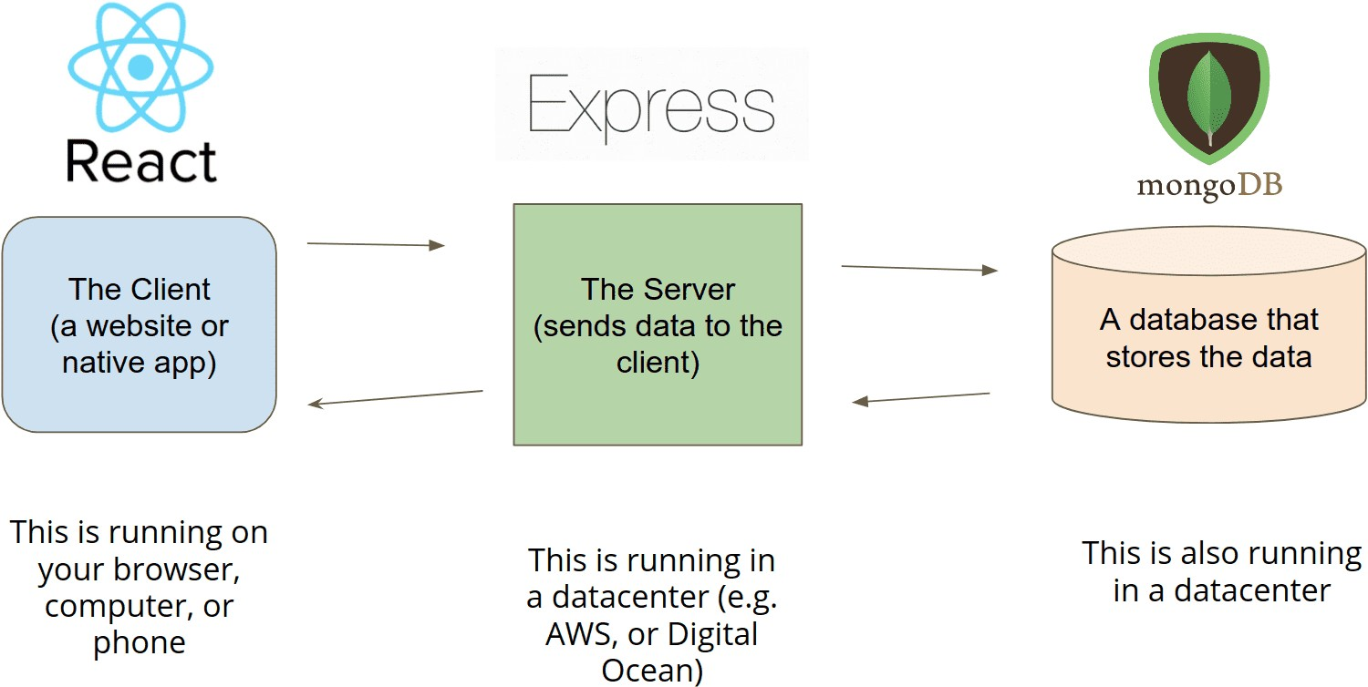

**PROJECT PROGRESS**

**Creating the Frontend of the site:**

1. **Developing the App.js** -This is the file for App Component. App Component is the main component in React which acts as a container for all other components. src/App.css : This is the CSS file corresponding to App Component. build: This is the folder where the built files are stored

**Code:**

import React from "react";

import "./App.css";

// import Router

import { BrowserRouter as Router, Route, Switch } from "react-router-dom";

// import Component

import Header from "./component/Header";

import Footer from "./component/Footer";

import ScrollToTop from "./component/ScrollToTop";

// import Pages

import Home from "./Pages/Home";

import ReactHooks from "./Pages/ReactHooks";

import UiUx from "./Pages/UiUx";

import FormExample from "./Pages/FormExample";

function App() {

return (

<React.StrictMode>

<Router>

<Header />

<ScrollToTop>

<Switch>

<Route exact path="/" component={Home} />

<Route exact path="/react-hooks" component={ReactHooks} />

<Route exact path="/ui-ux" component={UiUx} />

<Route exact path="/form-example" component={FormExample} />

</Switch>

</ScrollToTop>

<Footer />

</Router>

</React.StrictMode>);

}

export default App;

**2.Developing the Home.js –** This react component defines the basic homepage of the web portal. All the other components are embedded in this homepage.

**Code:**

import React from "react";

const Home = () => {

return (

<React.StrictMode>

<div className="main-page-content">

<div id="home">

<div id="particles-js"></div>

<div className="home-content-main">

<div className="table-cell">

<div className="container">

<div className="row home-row">

<div className="col-md-12 col-sm-12">

<div className="home-text wow fadeIn text-center">

<h1 className="cd-headline clip is-full-width">

<span

className="cd-words-wrapper"

style={{ width: "266px", overflow: "hidden" }}

>

<b className="is-hidden">Help'Em</b>

<b className="is-visible">Let You Be The Hero</b>

</span>

</h1>

</div>

<div className="parallax" data-velocity="-.1"></div>

<div className="parallax" data-velocity="-.5" data-fit="525"></div>

</div>

<div id="about">

<div className="about-content">

<div className="love-grid text-center">

<div className="container">

<div className="row">

<div className="col-md-12">

<div className="main-title text-center wow fadeIn">

<h3>Overview</h3>

<div className="underline1"></div>

<div className="underline2"></div>

<p>

Disaster situations are threatening, highly dynamic, and with uncertain developments. It is difficult to predict human behaviour when hit by a Disaster as this depends on unknown and irrational factors. National disaster task forces such as NDRF have been experiencing such situations while evacuating the areas under the influence of disasters like earthquakes, floods, cyclones, and other calamities.

It is vital to evaluate the disaster-struck areas, understand the requirements at the ground level and use the resources present at the moment optimally. There is a requirement to create a system to manage and minimize the aftermaths of a disaster.

So, we present a solution to this by developing a platform where various people grant their homes, shops, etc., for shelter purposes. The platform can be used by the family of the victim to find his location or whether he is safe or not.

The platform will help in improving the facilities provided to the victims by sheltering them and managing the crowd effectively

</p>

</div>

</div>

</div>

<div className="row love-row wow fadeIn">

<div className="col-md-3 col-sm-6">

<div className="love-details" data-wow-delay=".1s">

<h3>Frightened Crowd</h3>

<div className="underline1"></div>

<img

src="assets/img/shelter.png"

alt="Help'Em"/>

<div className="underline2"></div>

<p>When a huge disaster strikes,people are usually in a panic, and controlling crowd becomes a difficult task.</p>

</div>

</div>

<div className="col-md-3 col-sm-6">

<div className="love-details" data-wow-delay=".3s">

<h3>Availability of Shelter </h3>

<div className="underline1"></div>

<img

src="assets/img/shelter.png"

alt="Help'Em"/>

<p>During disasters, finding a shelter is very difficult task</p>

</div>

</div>

<div className="col-md-3 col-sm-6">

<div className="love-details" data-wow-delay=".2s">

<h3>Finding your loved ones</h3>

<div className="underline1"></div>

<img

src="assets/img/shelter.png"

alt="Help'Em"/>

<div className="underline2"></div>

<p>In such an adverse condition finding your relatives and family members could be really tough.</p>

</div>

**Image Resources:**

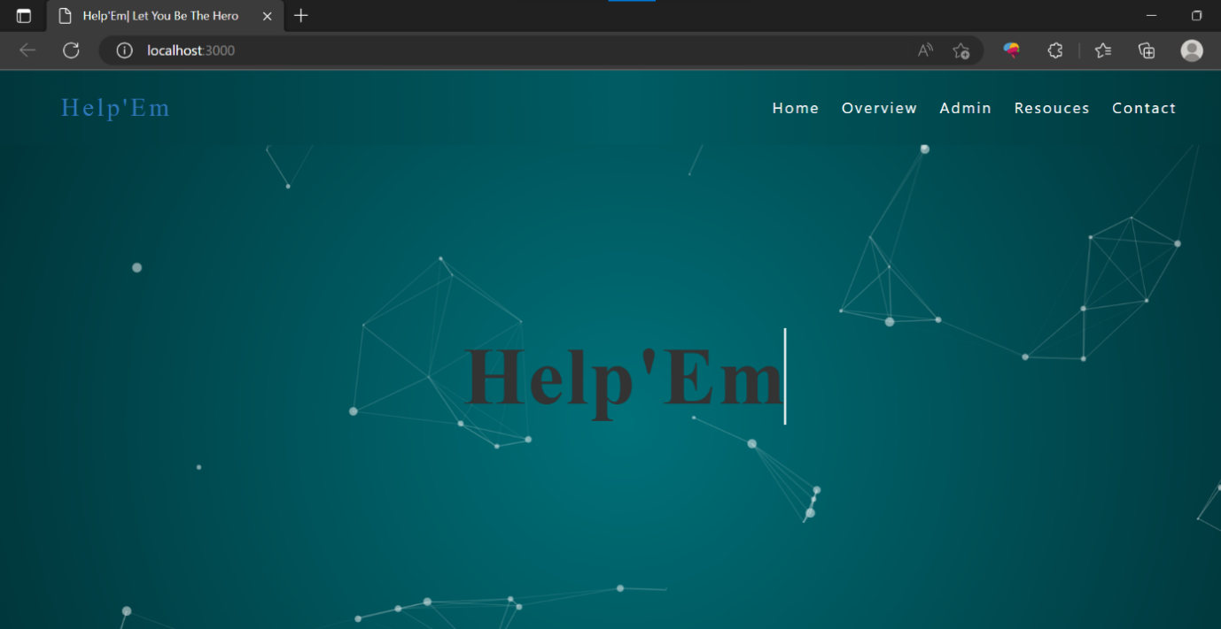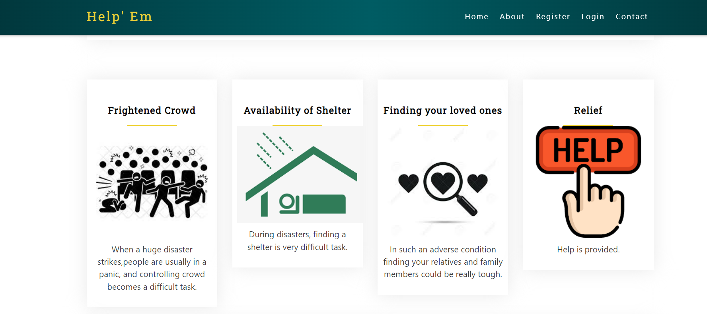

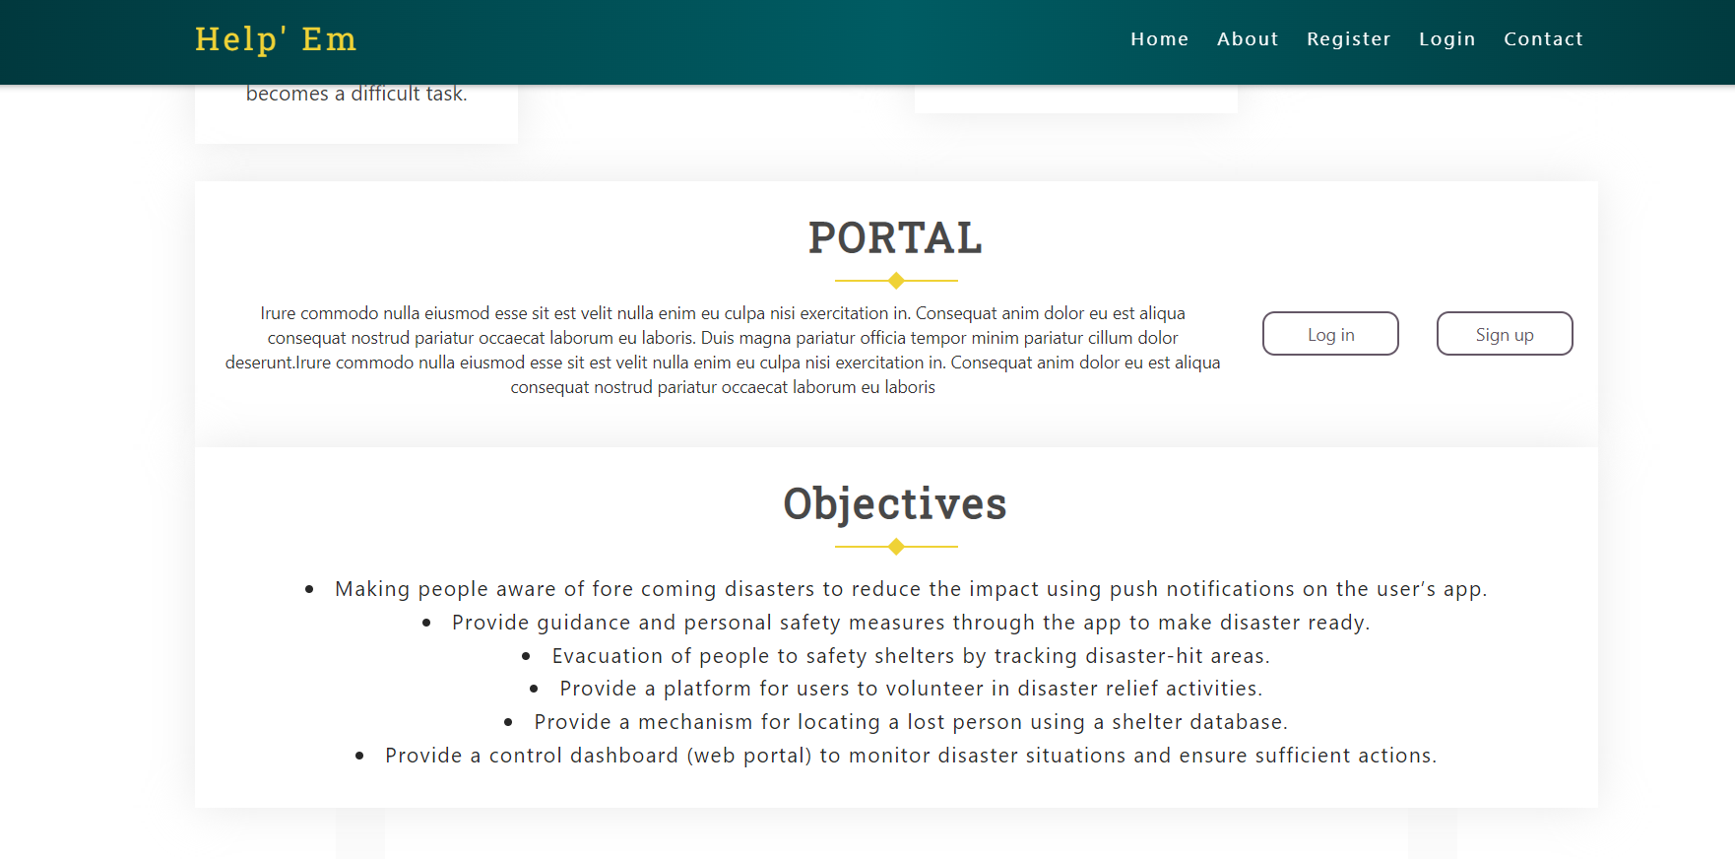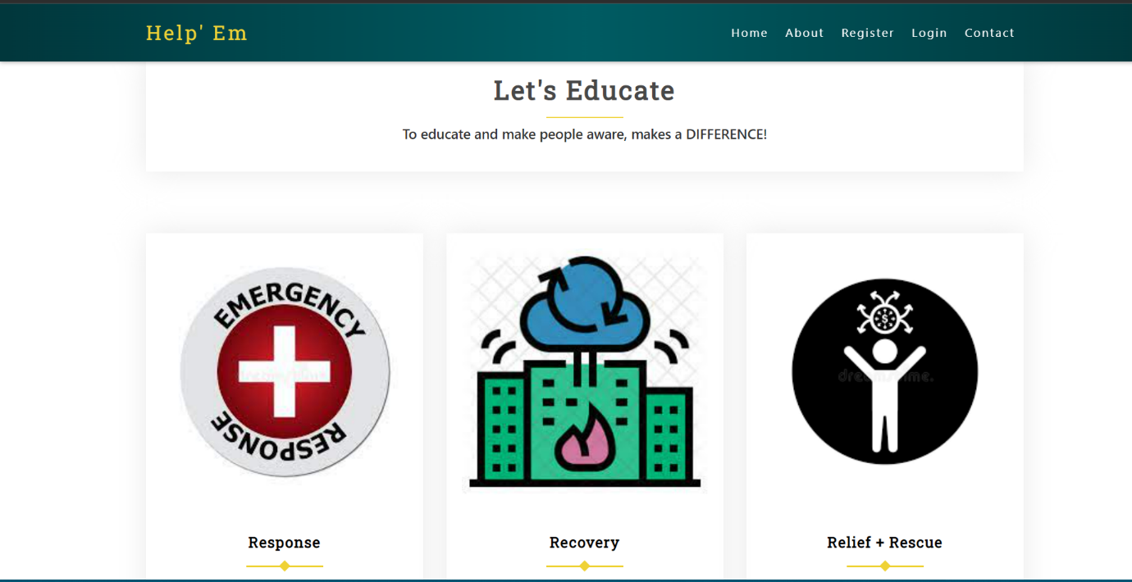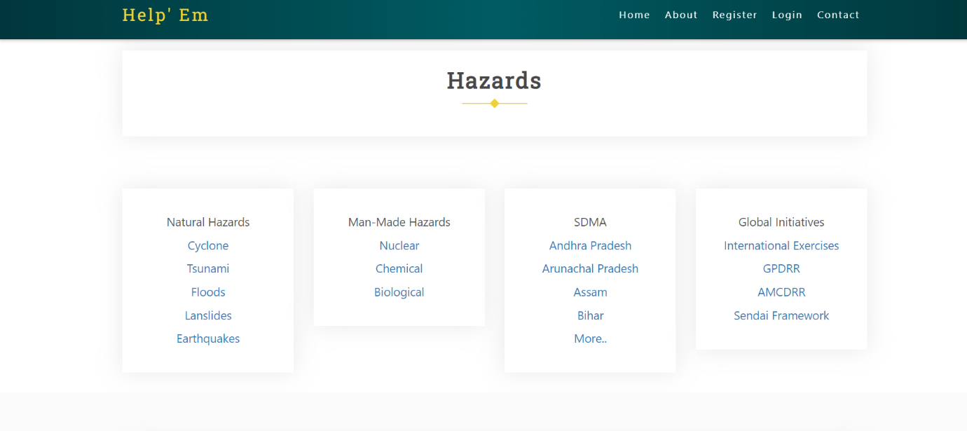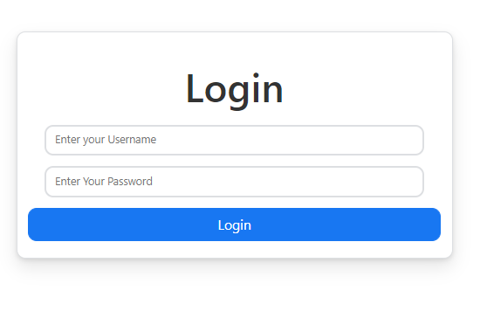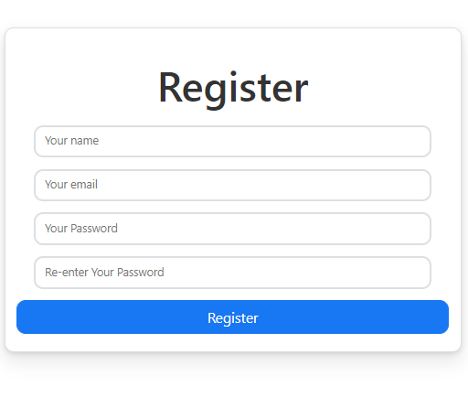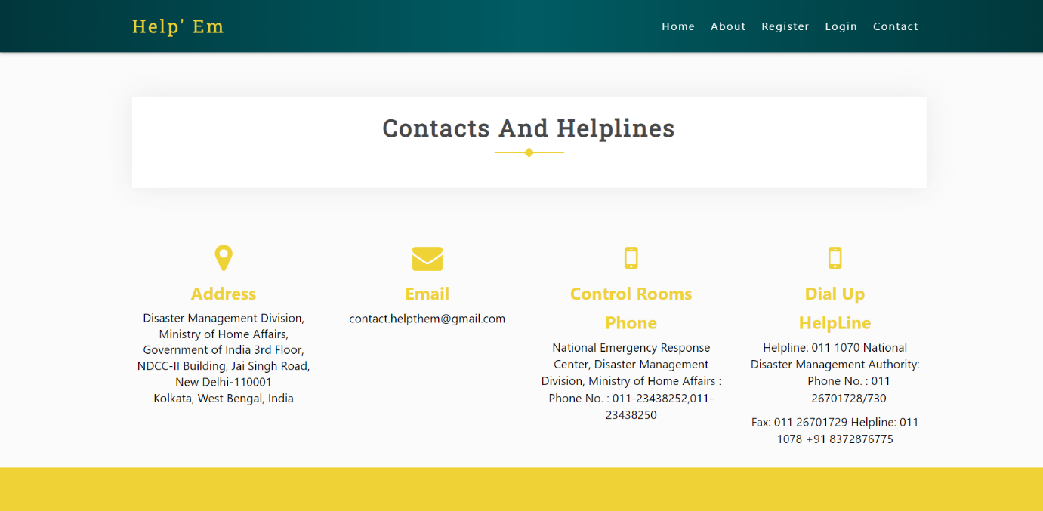

**Next steps:**

* Creating a database in a NoSQL database mongoDB.
* Developing a server in Node.js and admin route and victim route are created.
* Express to integrate the functioning of frontend and backend.
* Facilitate login on the portal for rescue teams and people using OAuth.

**References:**

* <https://reactjs.org/docs/getting-started.html>
* <https://nodejs.org/en/download/>
* <https://usdma.uk.gov.in/>
* <https://github.com/Ronak-59/Helping-Hands-SIH2018>